SET 11 – PRODUCT CATEGORY ANALYSIS
Aim
To analyze sales conversion across different product categories using a pie chart, funnel chart, and table in R.
Algorithm
- Create the product category and sales dataset.
- Create a pie chart to show sales distribution.
- Create a funnel-style chart to compare category sales.
- Display the sales data in a table.
- Add suitable labels and titles.
R Program
library(ggplot2)

product <- data.frame(
Category=c("Electronics","Clothing","Appliances"),
Sales=c(50000,35000,40000)
)

pie(product$Sales,
labels=product$Category,
main="Product Category Sales")

ggplot(product, aes(reorder(Category, Sales), Sales, fill=Category)) +
geom_bar(stat="identity") +
coord_flip() +
labs(title="Product Category Sales Funnel",
x="Category", y="Sales")

print(product)

OUTPUT:
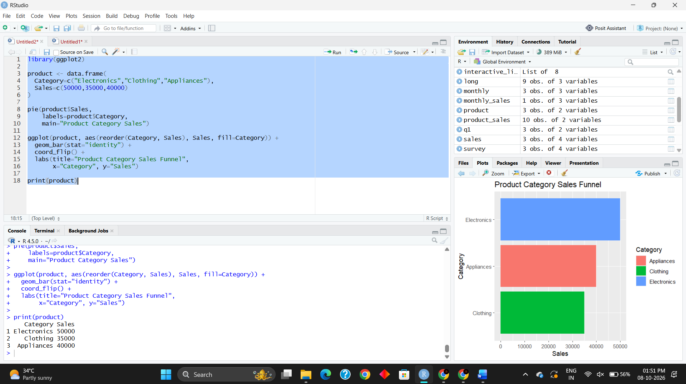
Result
The pie chart successfully shows the sales distribution among product categories. The funnel-style bar chart compares the sales of Electronics, Clothing, and Appliances, and the table displays the sales data.

